MVR-33A Form
Military/Veteran’s
Registration Plate Application
Information and Guidance

Guidance for completing the form
and what to look for to verify veteran
meets the qualifications for the license plate.

Updated April 2017 for the MVR-33A (Rev.2/2016)
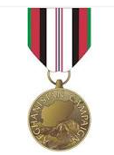
Afghanistan Veteran
Look for the Afghanistan Campaign Medal or ACM on the DD-214.
(Boots on the ground is NOT a requirement of the medal.)

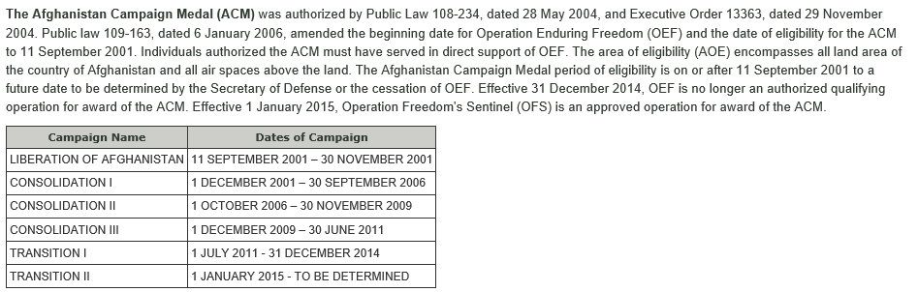

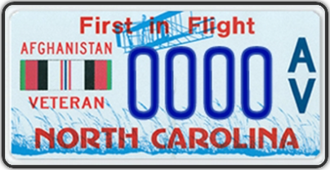

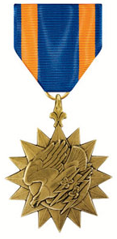
Air Medal Recipient
Look for the Air Medal or AM on the DD-214.

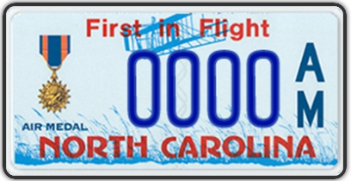
The Air Medal is awarded to any person who, while serving in any capacity in or with the armed forces of the United States, shall have distinguished themselves by meritorious achievement while participating in aerial flight.
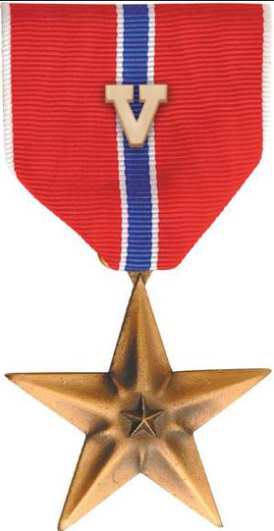
Bronze Star Combat Recipient
Look for the Bronze Star Medal with “V” Device, Bronze Star Medal with Combat “V”, Bronze Star Medal with Combat Distinguishing Device “V”, or BSM w/V, on the DD-214.

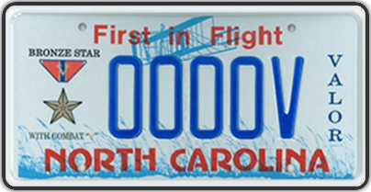

The Bronze Star Medal is an individual military award of the United States Armed Forces. It may be awarded for acts of heroism, acts of merit, or meritorious service in a combat zone. The Bronze Star Medal is the fourth-highest individual military award and the ninth-highest by order of precedence in the US Military. When awarded for acts of heroism, the medal is awarded with the “V” device.

Bronze Star Recipient
Look for the Bronze Star Medal or BSM on the DD-214.
(A Bronze Star attached to another medal, is not the same as a Bronze Star Medal. The BSM is a standalone medal.)

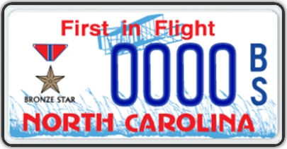

The Bronze Star Medal is an individual military award of the United States Armed Forces. It may be awarded for acts of heroism, acts of merit, or meritorious service in a combat zone. The Bronze Star Medal is the fourth-highest individual military award and the ninth-highest by order of precedence in the US Military.
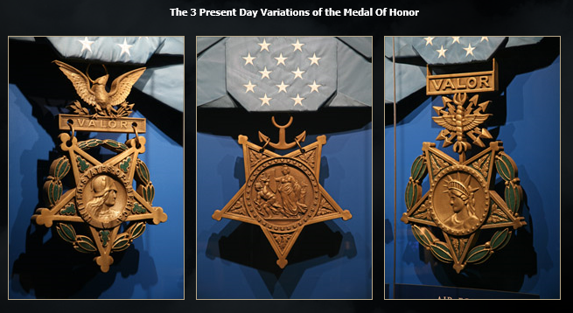
Congressional Medal of Honor
Look for the Congressional Medal of Honor, listed on the DD-214 or DD-215, or the display certificate or citation write up.

The Congressional Medal of Honor is the highest award for valor in action against an enemy force which can be bestowed upon an individual serving in the Armed Services of the United States. Generally presented to its recipient by the President of the United States of America in the name of Congress.

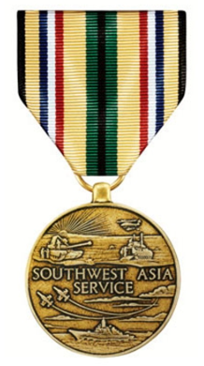
Desert Storm Veteran
Look for the Southwest Asia Service Medal, or SWASM on the DD-214. (Boots on the ground is NOT a requirement.)

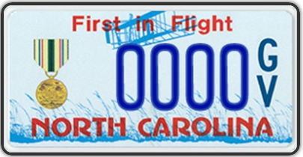

The medal is awarded to any member of the U.S. Armed Forces for service in prescribed geographical parts of the Middle East during Operations DESERT SHIELD, DESERT STORM, PROVIDE COMFORT, and the Southwest Asia Cease Fire Campaign. To be eligible, a Service member must have been: attached to or regularly serving for one or more days with an organization participating in ground/shore military operations; attached to or regularly serving for one or more days aboard a naval vessel directly supporting military operations; actually participating as a crew member in one or more aerial flights directly supporting military operations in the areas designated; or serving on temporary duty for 30 consecutive days or 60 nonconsecutive days, except, if a waiver is authorized for personnel participating in actual combat. (The NC DMV lists Desert Storm as the period beginning Aug. 2, 1990 and ending April 11, 1991.)
Disabled Veteran
Issuable to a veteran with a 100% service connected rating (100% schedular) or with Individual Unemployability (IU). P&T is NOT a requirement.
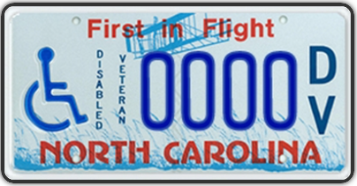

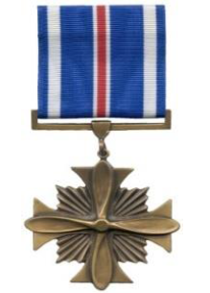
Distinguished Flying Cross
Look for Distinguished Flying Cross, or DFC on the DD-214.

Awarded to any officer or enlisted member of the United States Armed Forces who distinguishes himself or herself in support of operations by "heroism or extraordinary achievement while participating in an aerial flight”.

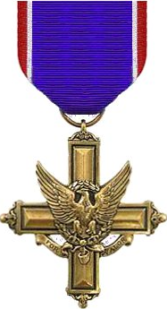
Distinguished Service Cross
Look for Distinguished Service Cross, or DSC on the DD-214.

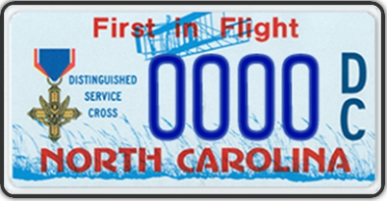

The Distinguished Service Cross is awarded for extraordinary heroism not justifying the Medal of Honor; and the act or acts of heroism must have been so notable and have involved risk of life so extraordinary as to set the individual apart from his or her comrades. This award is given to a member of the U.S. Army (and previously, the U.S. Army Air Force and the U.S. Air Force).

Ex-Prisoner of War
Look for Prisoner of War, or POW, or POWM on the DD-214.

Awarded to any person who was a prisoner of war after April 5, 1917. It is awarded to any person who was taken prisoner or held captive while engaged in an action against an enemy of the United States; while engaged in military operations involving conflict with an opposing Armed Force; or while serving with friendly forces engaged in armed conflict against an opposing Armed Force in which the United States is not a belligerent party. As of an amendment to Title 10 of the United States Code in 2013, the medal is also awarded for captivity under circumstances "which the Secretary concerned finds were comparable to those circumstances under which persons have generally been held captive by enemy armed forces during periods of armed conflict." The person's conduct, while in captivity, must have been honorable.
Gold Star Lapel Button
I haven’t found anything concrete on this, but they have to complete DD Form 3 to obtain the Gold Star Lapel Button. I would imagine they will receive a letter honoring their family member’s service upon the military issuance of the Gold Star Lapel Button, and we would certify the DMV application based upon this award letter.

The Gold Star Lapel Button is given to identify widows, parents and next of kin of members of the Armed Forces of the U.S. who lost their lives during a period of war (or during Operations recognized by DOD in establishing eligibility). DD Form 3 must be completed and submitted to the appropriate address on the application.
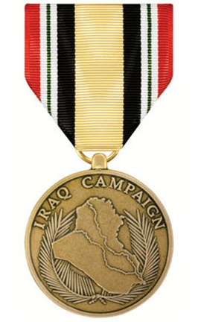
Iraq Veteran
Look for the Iraq Campaign Medal or ICM on the DD-214. (Boots on the ground is NOT a requirement.)

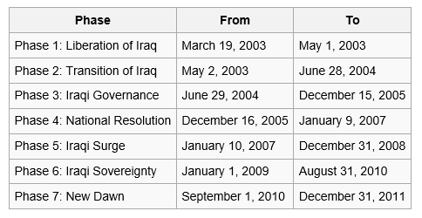
The Iraq Campaign Medal (ICM) is authorized for service members serving in direct support of Operation Iraqi Freedom (OIF) on/after 1 September 2010 for Operation New Dawn (OND). The area of eligibility encompasses all land area of the country of Iraq, and the contiguous water area out to 12 nautical miles, and all air spaces above the land area of Iraq and above the contiguous water area out to 12 nautical miles. The ICM period of eligibility is on or after 19 March 2003 to 21 December 2011.

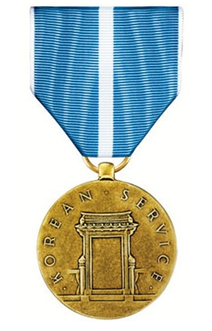
Korean Conflict
Look for the Korean Service Medal, or KSM on the DD-214. (Boots on the ground NOT required.)

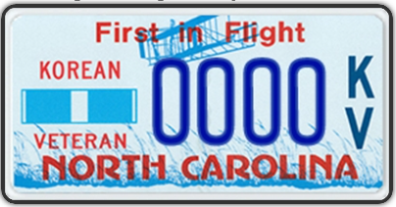

The Korean Service Medal is awarded for participation in the Korean War for service between 6/27/50 and 7/27/54. It is awarded to any U.S. service member, who performed duty in the Republic of Korea or in waters immediately adjacent thereto, by permanent assignment or temporary duty for 30 consecutive days or 60 nonconsecutive days, or who were with a unit having directly supported the military efforts in Korea, or who were in direct combat with the enemy (division, ship, or air).

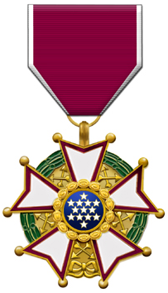
Legion of Merit
Look for the Legion of Merit or LM on the DD-214.

BACKGROUND:
The Legion of Merit, the first United States decoration created specifically for award to citizens of other nations, was established by an Act of Congress of July 20, 1942, amended by an executive order of March 15, 1955. It is conferred on officers and enlisted men of the armed forces of the United States and on nationals of other countries "who shall have distinguished themselves by exceptionally meritorious conduct in the performance of outstanding services" since Sept. 8, 1939, the date of the president's proclamation of the state of emergency that led to World War II. The Legion of Merit may be awarded for combat or noncombat services; in the case of American military personnel, if the award is for combat service it is shown by the wearing of a combat "V" device.
The Legion of Merit was originally ranked directly below the Distinguished Service Medal in the Navy's pyramid of honor. This was changed by Navy Directive Number 49 of Jan. 28, 1946, which placed the Legion of Merit immediately below the Silver Star, thus making it the Navy's fifth ranking decoration.
The Legion of Merit is also the first award to have different degrees. If a holder of the Legion of Merit in one degree is subsequently given another such award, it is never in a degree lower than the original one. The degrees of chief commander and commander are conferred on members of foreign governments only and are awarded for services comparable to those for which the Distinguished Service Medal is given to members of the United States armed forces.
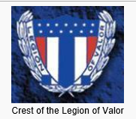
Legion of Valor
Look for one of the following medals on the DD-214 or appropriate documentation: Congressional Medal of Honor, Distinguished Service Cross (DSC), Navy Cross, Air Force Cross, or the Coast Guard Cross.

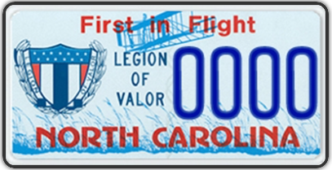

Issuable to a recipient of one of the following military decorations: Congressional Medal of Honor, Distinguished Service Cross, Navy Cross, Air Force Cross, or the Coast Guard Cross.

Partially Disabled Veteran
Issuable to a veteran who suffered a service connected disability of less than 100%. Does not have to be a compensable rating.

Pearl Harbor Survivor
Need personnel records showing veteran was stationed at Pearl Harbor, Hawaii, during the attack 12/7/1941.

Issuable to a veteran of the Armed Forces of the United States who was present at and survived the attack on Pearl Harbor on December 7, 1941.

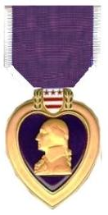
Purple Heart Recipient
Look for Purple Heart or PH on the DD-214.

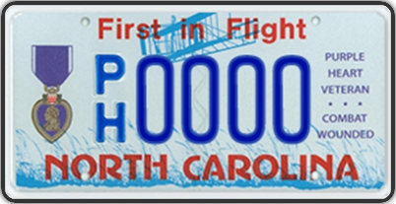
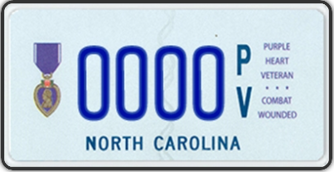

Motorcycle Plate
Awarded for being wounded or killed in any action against an enemy of the United States or as a result of an act of any such enemy or opposing armed forces.
Silver Star Disabled Veteran
Look for Silver Star on the DD-214, and the veteran must have a 100% SC rating from the VA.

The Silver Star is awarded to a person who, while serving in any capacity with the U.S. Army, is cited for gallantry in action against an enemy of the United States while engaged in military operations involving conflict with an opposing foreign force, or while serving with friendly foreign forces engaged in armed conflict against an opposing armed force in which the United States is not a belligerent party.

Silver Star Recipient
Look for Silver Star on the DD-214.

The Silver Star is awarded to a person who, while serving in any capacity with the U.S. Army, is cited for gallantry in action against an enemy of the United States while engaged in military operations involving conflict with an opposing foreign force, or while serving with friendly foreign forces engaged in armed conflict against an opposing armed force in which the United States is not a belligerent party.
US Military Air Force Veteran
Honorable or General Under Honorable Conditions discharge from the US Air Force.

US Military Army Veteran
Honorable or General Under Honorable Conditions discharge from the US Army.

US Military Coast Guard Veteran
Honorable or General Under Honorable Conditions discharge from the US Coast Guard.

US Military Marine Veteran
Honorable or General Under Honorable Conditions discharge from the US Marine Corps.

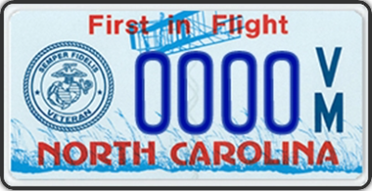

US Military Navy Veteran
Honorable or General Under Honorable Conditions discharge from the US Navy.

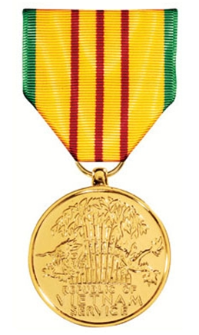
Vietnam Era
Look for the Vietnam Service Medal or VSM on the DD-214.
(Boots on the ground is NOT a requirement for this medal.)

The VSM was awarded to all members of the U.S. Armed Forces who served in Vietnam or contiguous waters or airspace after July 3, 1965, and before March 28, 1973. In addition, personnel serving in Thailand, Laos, or Cambodia in direct support of operations in Vietnam during the same time period were also eligible for the VSM. **Service members who qualified for the Armed Forces Expeditionary Medal (AFEM) by reason of service in Vietnam between July 1, 1958 and July 4, 1965, may exchange their AFEM for the VSM, essentially making the VSM retroactive to July 1, 1958. The service member cannot receive both the VSM and AFEM for the same period of service in Vietnam.
War on Terror
Look for Global War on Terrorism Expeditionary Medal or GWOTEM on the DD-214. (Boots on the ground NOT required.)

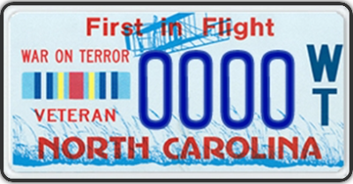

To be awarded the Global War on Terrorism Expeditionary Medal a military service member must perform duty in a deployed status and must participate in designated anti-terrorism operation for a period of either 30 consecutive or 60 non-consecutive days of duty. For those who were engaged in combat, killed, or wounded in the line of duty, the time requirement is waived. The term "deployed status" indicates either temporary or permanent orders to a duty station outside the borders of the United States of America with such duty being in direct support of anti-terrorism operations. For a service member to receive the Global War on Terrorism Expeditionary Medal, the deployment must also have taken place in a nation which is currently recognized as a base for anti-terrorism operations by the United States Department of Defense.

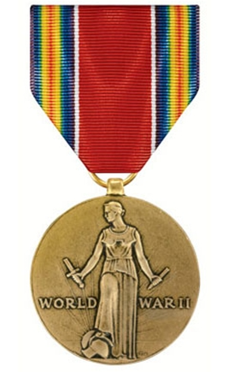
World War II Veteran
Look for World War II Victory Medal (or Ribbon) on the DD-214 or the WD AGO Form 53-55. (Boots on the ground NOT required.)

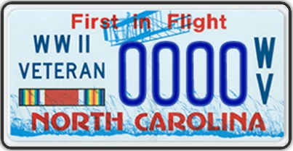

The WW II Victory Medal was awarded to all military personnel for service between 7 December 1941 and 31 December 1946.
Guidance for filling out the MVR-33A – License Plate Application Forms

Section 1
Veteran must choose which plate they wish to receive and provide documentation showing their eligibility for this license plate.
The * indicates they are entitled to ONE FREE plate per person. (Free plate applications can be faxed to the Raleigh DMV Office at (919)715-5185.)
The ** indicates there is no special fee for having a specialty plate, but they still have to pay the regular license fee. (The applications for these plates must be given back to the veteran to take to the DMV office, due to having to pay the DMV fees.)

White out or errors that have been marked out should not be submitted to the NCDMV for processing; if there are errors…redo the form.

No Social Security number or file numbers are required for the processing of this document.

If a veteran has just moved to NC & does not have the vehicle registered in the state yet, verify eligibility for the tag & the NCDMV will register the vehicle & process the MVR-33A.

Veteran needs to choose between a “First in Flight” background or the “First in Freedom” background.
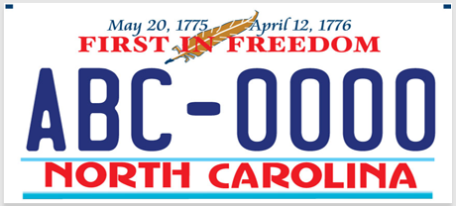

If the veteran chooses to have a personalized plate, they will be charged the personalization fee (even though it’s a free plate). They are allowed four (4) spaces for a personalized message _ _ _ _. It must contain at least one alpha character; it cannot be numbers only. The prefix/suffix for the specific plate will be the first/last letters on the plate, depending upon which plate they choose.

Guidance for the MVR-33A form continued…

Section 2
Must be completed with the veteran’s information and vehicle registration and insurance information. (The veteran’s name must be on the title of the vehicle; joint ownership is accepted.)
All this information can be found on the vehicle registration card, except for the veteran’s driver’s license number.
The veteran must sign their name. Their signature is certifying they have liability insurance.

Section 3
To be completed by the accredited service officer and signed in blue ink.
You must write in which license plate the veteran has chosen. Then on the designated lines, print and sign your name followed by, “designee for James E. Prosser, Director NCDVA”, and date it.

Special Notation
Veterans in receipt of “Temporary 100%” disability due to United States Department Veterans Affairs (USDVA) convalescent rating, 38 CFR 4.29 or 38 CFR 4.30, are NOT entitled to the Disabled Veterans free tag. These veterans should see their physician for a temporary handicap placard if needed.

Veterans whose DD-214 does not show the medal they are applying for on the license plate application, but who received the medal or is eligible for the medal, should also apply concurrently to the Board of Corrections, with proper documentation, to receive a DD-215 correction of their discharge documents.

